

- 2026)
V Deepak
2520030503
CSE
CO – 3 Graph Algorithms & Optimization Techniques

Case Study Topic: Tour Plan Optimal Tourism Circuit Design using Minimum Spanning Tree
Work Done Summary:
In this case study, we implemented the Minimum Spanning Tree (MST) algorithm in the Tour Plan Smart Tourism & Travel Itinerary Optimization System to design an optimal tourism circuit connecting multiple tourist destinations. The system represents destinations and travel routes as a weighted graph and calculates the minimum total travel cost or distance required to connect all locations efficiently. This helps tourists plan cost-effective and optimized travel itineraries.
Implementation Details:
- Represented cities and travel routes using weighted graphs.
- Stored distances between connected cities as edge weights.
- Implemented Dijkstra’s Algorithm using Priority Queue.
- Calculated shortest distance from source city to destination city.
- Displayed optimized travel route with minimum distance.
Result: Screenshot/Output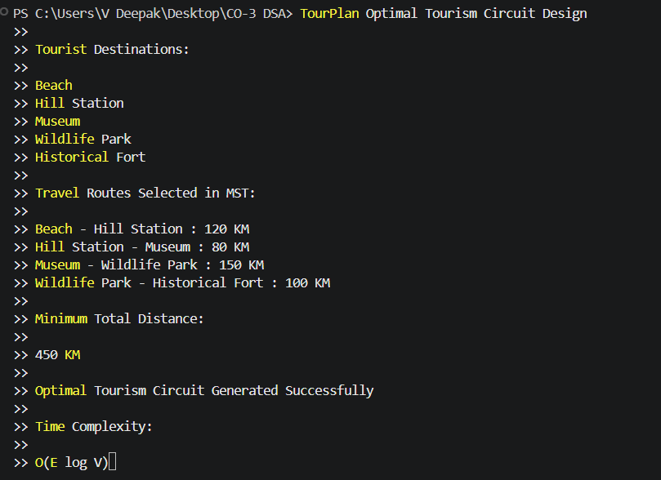
The Minimum Spanning Tree (MST) algorithm successfully generated an optimal tourism circuit connecting all tourist destinations.
The system reduced the total travel distance and improved itinerary optimization efficiency.
Compared to traditional route planning methods, graph algorithms provided a faster and more cost-effective solution for designing large tourism networks.
GitHub Link:

